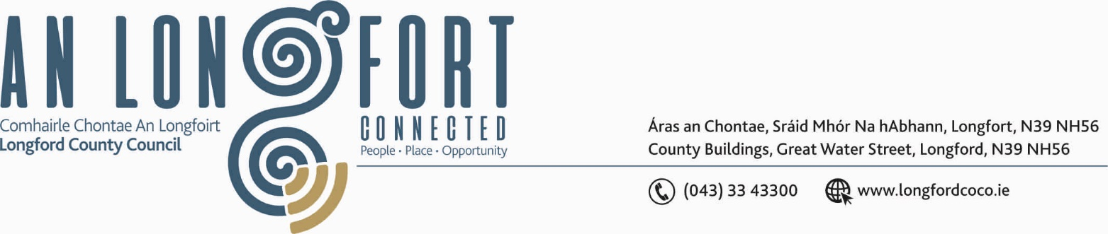

BALLYMAHON MUNICIPAL DISTRICT

19th July 2019.

To: Each Member of Ballymahon Municipal District.

Dear Member,

You are requested to attend Meeting of Ballymahon Municipal District to be held in Ballymahon Community Library, on Thursday, 25th July 2019 at
4.00 p.m. to transact business, as set out on the Agenda hereunder.

Yours sincerely,
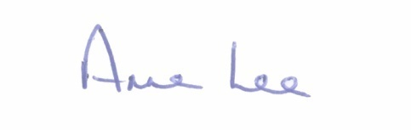

_______________
Anne Lee,
Meetings Administrator.

AGENDA

Prayer before meeting.

1. Confirmation of Minutes of the following Meetings of Ballymahon Municipal District -

- Municipal District Committee Meeting held on the 14th March 2019.
- Municipal District March Meeting held on the 14th March 2019.
- 2019 Annual Meeting held on the 17th June 2019
copies enclosed.

2. Matters arising from Minutes.

3. Declaration of Interest by Members.

4. Management Report - to follow.

5. Notices of Motions submitted by Councillors, as listed hereunder –

Councillor Mick Cahill.

"That Longford County Council takes the opportunity to install electric car charging infrastructure along with gas installation works in Ballymahon to facilitate on-street charging facilities as it is rolled out. Also, in Edgeworthstown as road works are being carried out."

"That Longford County Council carries out works at the junction –
Ardagh R393 and L1098 (moor), in the interests of road safety."

Councillor Gerard Farrell.

“That Longford County Council reviews their position on speed ramps in built up areas”

“That Longford County Council looks for immediate funding for roads in Council Housing estates.”

Councillor Paul Ross.
“That a Low Cost Safety Scheme be applied for at the junction of the Ballymulvey Road onto the Newcastle Road in Ballymahon to improve the sightlines on this junction.”
“That additional car parking spaces be provided for in St. Matthews Park, Ballymahon particularly on the east side of the estate.”
“That new footpaths be installed in Ardagh from the School down to the Heritage Centre as the current path is not fit for purpose and pose a trip hazard.”
Councillor Pat O’Toole.
“I call on Longford County Council to provide additional car parking spaces in St. Matthew's Park Ballymahon, specifically in front of house numbers 32 to 37 and to the right of No. 40 where there is green space available, also to mark out a clearway in front of St. Anne's Terrace to allow residents vehicle access from Main Street.”

“That Longford County Council considers setting aside a number of hours each week for a clean-up at Newcastle Bridge amenity area which is used extensively by walkers, cyclists, canoeists and is becoming popular as a picnic area.”

“That Longford County Council as a matter of urgency seek a site in close proximity to Ballymahon Town to build a small estate of affordable houses
i.e. 20/25 with a mix of 2, 3 and 4 bed with appropriate green space etc.”

5. Correspondence – circulated.
(i) Correspondence received from Irish Rail regarding the car park at Edgeworthstown Railway Station.



